ASSIGNMENT NO:06

Q.1. What are keywords in python? Using the keyword library, print all the python keywords.

Ans 1. Keywords are the reserved words in python that have special meaning. They cannot be used as name of variable.

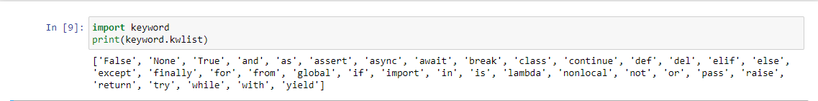

Q.2. What are the rules to create variables in python?

Ans 2. 1. Variable name should either start with Alphabets or Underscore(_).

2. It should not start with the digits.

3. Variable name contains alphanumeric and underscore.

4. it is case sensitive.

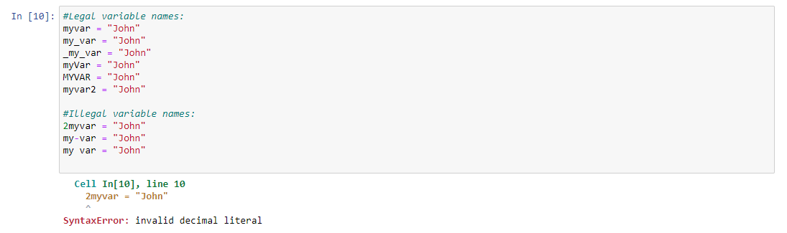

Q.3. What are the standards and conventions followed for the nomenclature of variables in

python to improve code readability and maintainability?

Ans. 3. 1. Variable name should either start with Alphabets or Underscore(_).

2. It should not start with the digits.

3. Variable name contains alphanumeric and underscore.

4. it is case sensitive.

Q.4. What will happen if a keyword is used as a variable name?

Ans 4. It will throw a syntax error if we use keyword as a variable name.

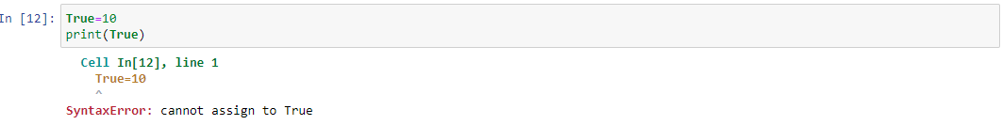

Q.5. For what purpose def keyword is used?

Ans 5. It is used to create or define a function.

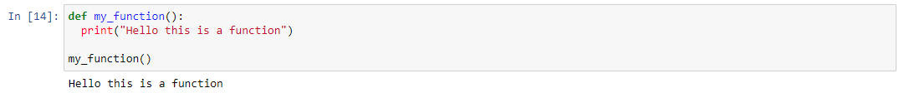

Q.6. What is the operation of this special character ‘\’?

Ans 6. This character is backlash, it is used to differentiate the file location in the network path or URL.

Q.7. Give an example of the following conditions:

(i) Homogeneous list

(ii) Heterogeneous set

(iii) Homogeneous tuple

Ans 7. Homogeneous list: It is a list containing elements of same type.

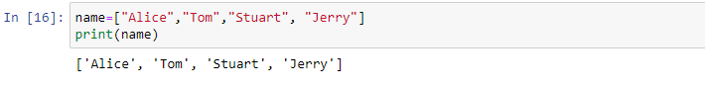

Heterogeneous set: It is a set containing elements of different types.

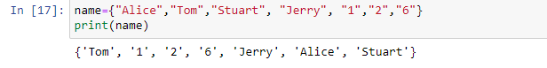

Homogeneous tuple: It is a tuple containing elements of same type.

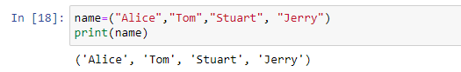

Q.8. Explain the mutable and immutable data types with proper explanation & examples.

Ans 8. Mutable data types: Elements can be changed after it is created.

Eg: List, set, dictionary.

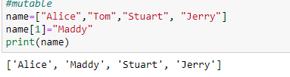

Immutable data types: Elements cannot be changed after it is created.

Eg: Tuple, int float, bool.

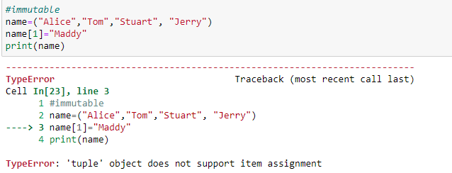

Q.9. Write a code to create the given structure using only for loop.

Ans 9.

Q.10. Write a code to create the given structure using while loop.

Ans 10.